**DESIGN**

1. **Sequence Diagram**

* A sequence diagram shows the interaction between the objects. It also shows in what order the operation is performed.
* The sequence diagram for Suraksha is as follows.

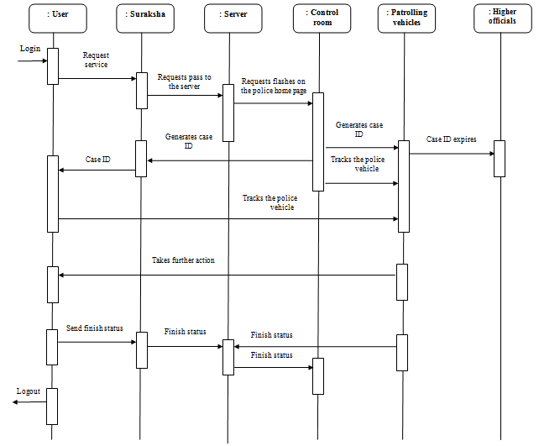

Figure 1: Sequence diagram for Suraksha

* When the user logs in, he/she requests service through the app.
* The app is connected to the server through which the requests are monitored by the police control room.
* For each request, a case id is generated which is sent to the user and the patrolling vehicles at the same time.
* If the time span of the case id expires, it is forwarded to the higher officials.
* If not, the user and the control room can track the patrolling vehicle through this case id.
* These vehicles reach the destination and monitor the case further.
* Once the case is closed, a finished report is send to the app.
* The user logs out.

**2. Dataflow Diagram**

* It is a traditional representation of how information flows within a system.
* It helps us to know about the good amount of system requirements graphically.

**2.1 Level 0**

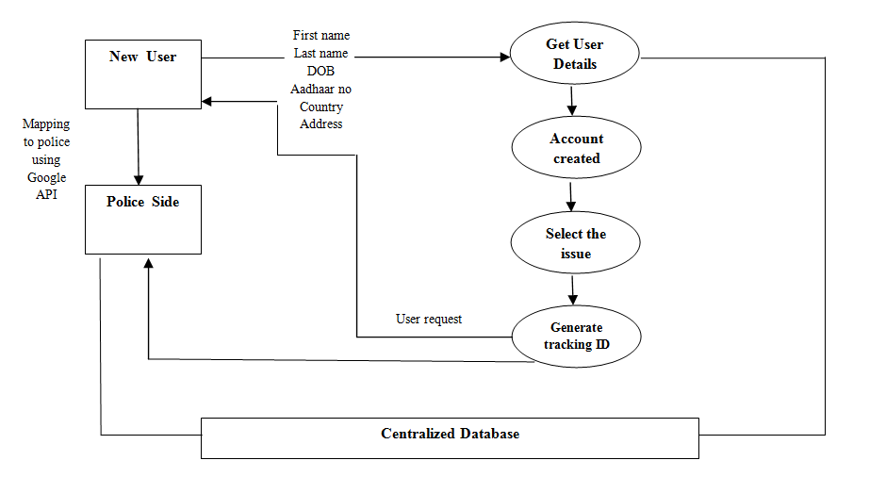**Figure 2:** User and Police registration

* The level 0 of a dataflow diagram is a simple representation of the whole system.
* When a user creates an account with his basic details and once the account is created he can select the type of issue or the incident that has taken place.
* The user is connected to nearest police station using Google Map API’s and a tracking ID is generated for each user.
* Every user record is reflected on the police system which will be recorded in the Centralized Database.

**2.2 Level 1**

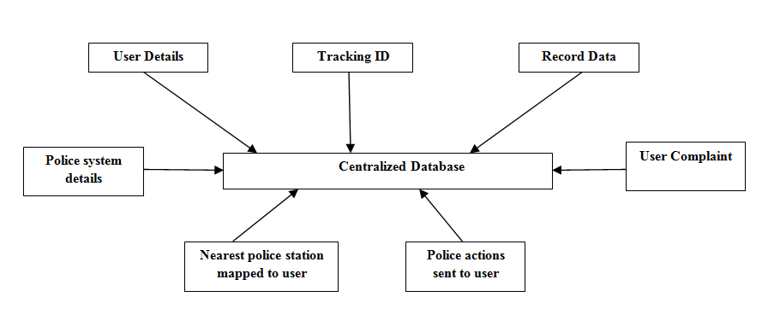**Figure 3:** Connection to centralized DB

Level 1 contains the lower level functions decomposed from major functions.

**2.3 Level 2**

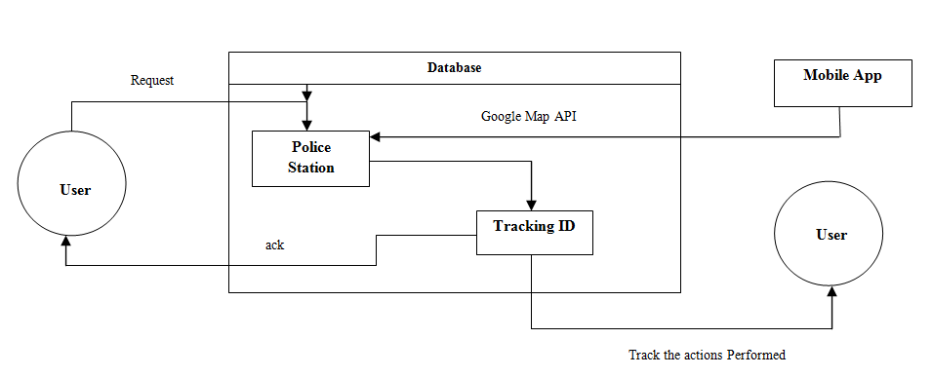**Figure 4:** Solving the case

Each process on the level 1 diagram is investigated in more detail to give a greater understanding of the activities and data flow. Normally processes are decomposed where:

* There are more than six data flows around the process.
* The process name is complex or very general which indicates that it incorporates a number of activities.

**3. Block Diagram 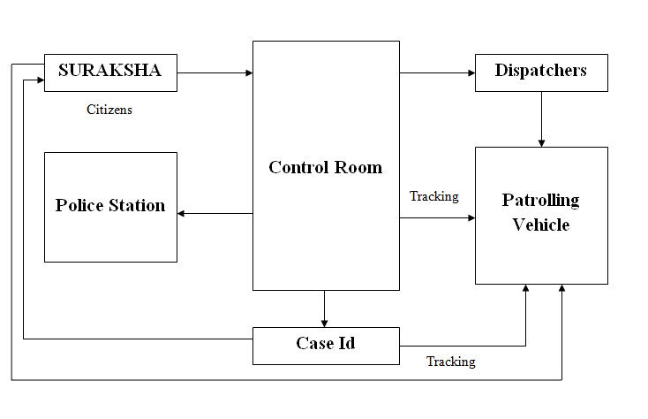 Figure 5:** Block diagram of Suraksha

**Suraksha:** A citizen who becomes a victim to any the negative events, shall login to the application and ask for services.

**Control Room:** There will be certain officials/operators in the police control room who will receive all these requests. The requests will be listed in order of their severity. The operators will assign a particular case to a group of dispatchers. For every case, a case-id will be generated.

**Dispatchers:** As soon as they are assigned to a case, they dispatch in their patrolling vehicle to the location where the incident has taken place.

**Patrolling Vehicles:** Each patrolling vehicle will have GPS installed; its location can be tracked by the operators in the control room and by the victim on the application.

**Case ID:** For every case, the operators create a case-id, which will be given to the dispatchers in the patrolling vehicle and to the victim on the application. Each case-id will have a lifespan. If the case is not solved within that lifespan, it will be automatically passed on to the higher officials.

**Police Station:** Once the case is solved, the operators in the control room inform in the police station about it. The police in the police station will have complete visibility of the case. In case any further action is needed, it will be taken.